

Lab 06

Graphical Report of Activities



Tirumala reddy konireddy

divya sree vintha

krishna chaitanya nalluri

syamala reddy arimanda

We tried working with project related data for this lab assignment.For our project purpose, we are doing alert services and a game service for physically challenged people. As part of this we had trained and tested three gestures for notifying hunger, thirst and wish to play to game.

As part of this lab assignment we had tried two types of graphical representation of number of gestures made at a particular time in a day.

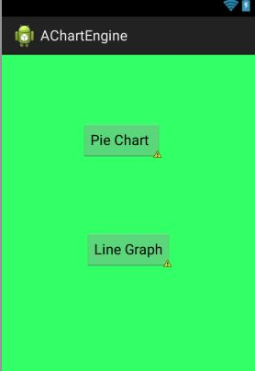

1. **Line graph :**

Here we are displaying number of Hunger gestures, number of game requests and number of thirsty gestures made by the user in the below graph.

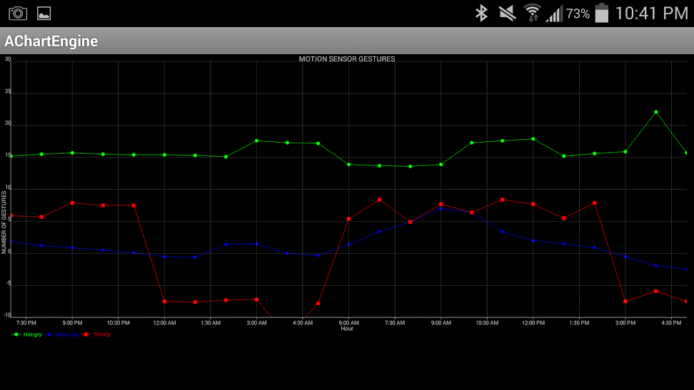

1. **Pie graph :**

Here, we are displaying the above details for all the day in a pie graph as below.

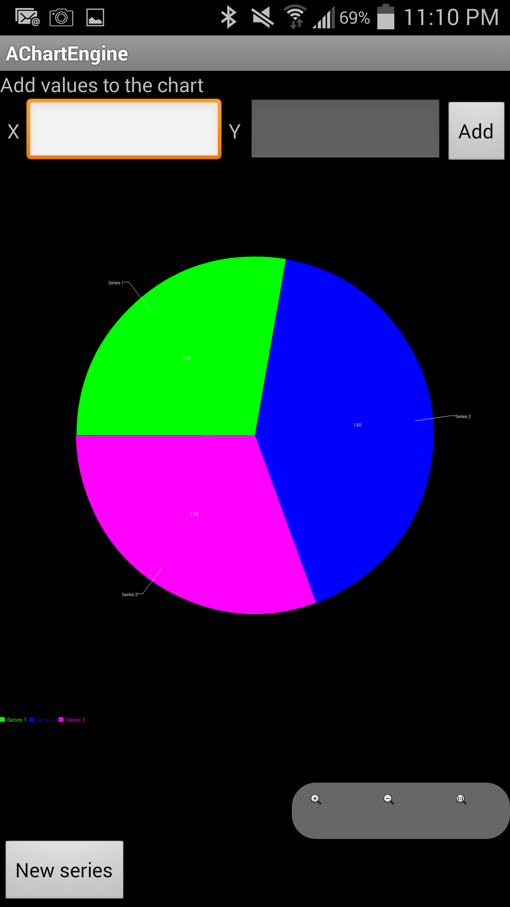

We are now doing integrate the above charts into our motion controlled Gesture App as below.

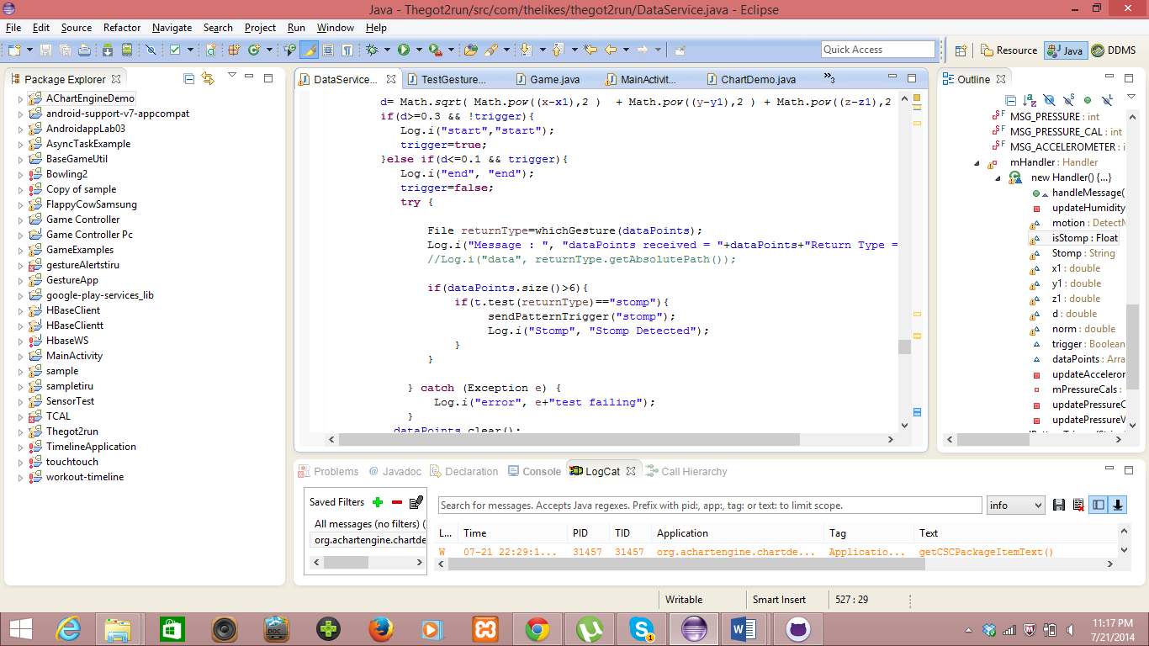

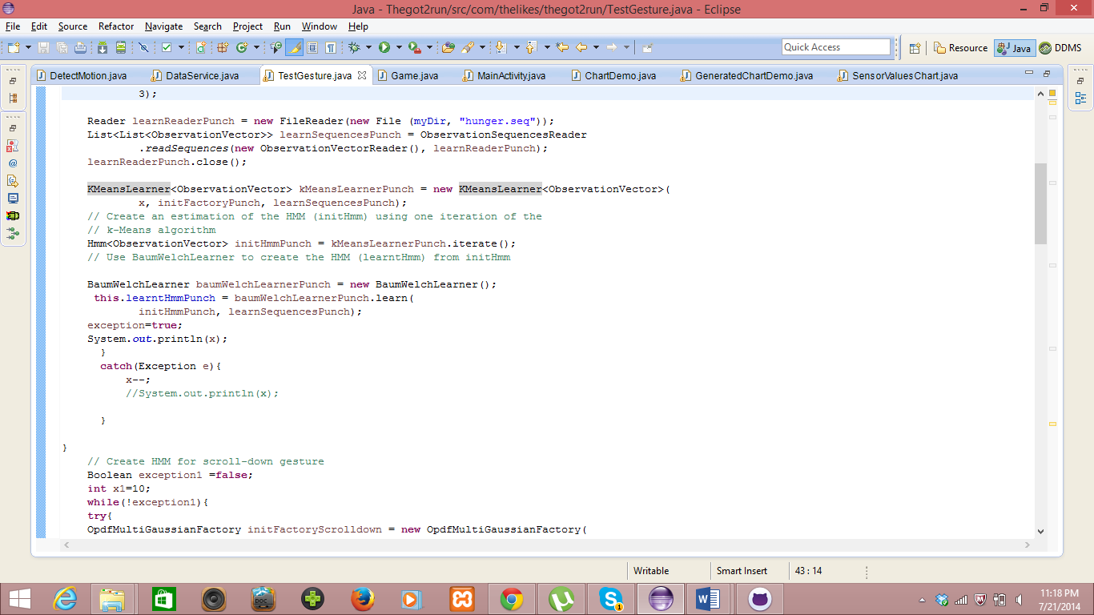

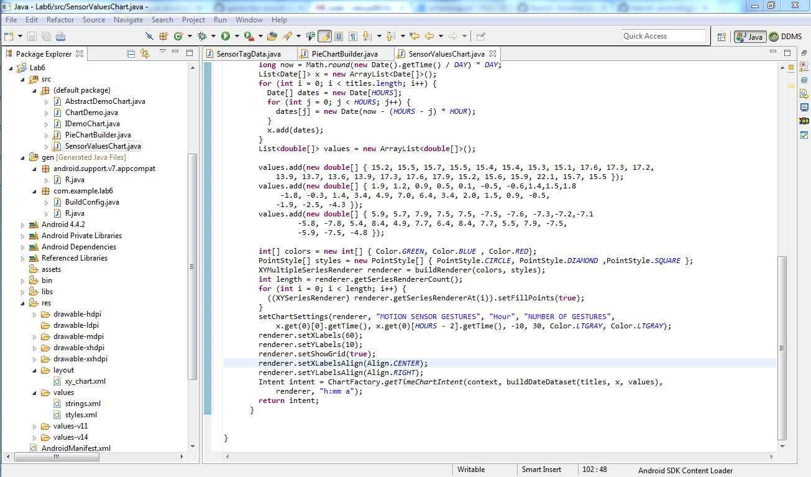

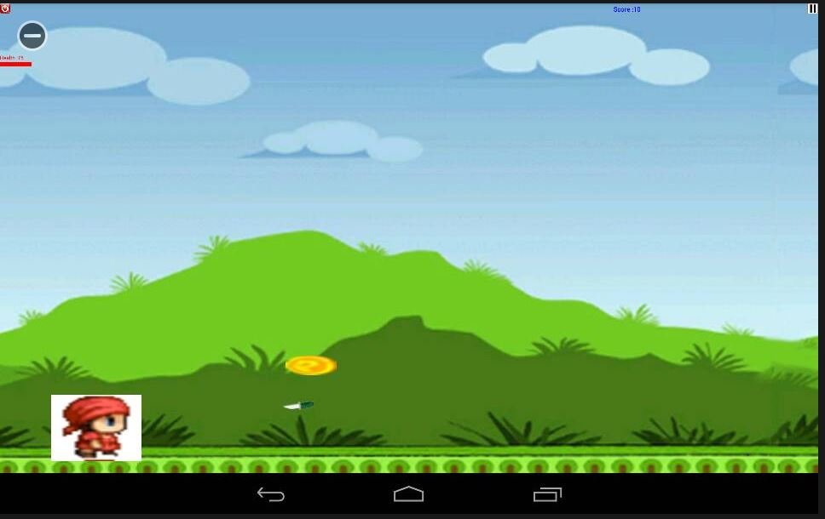

**Jump**

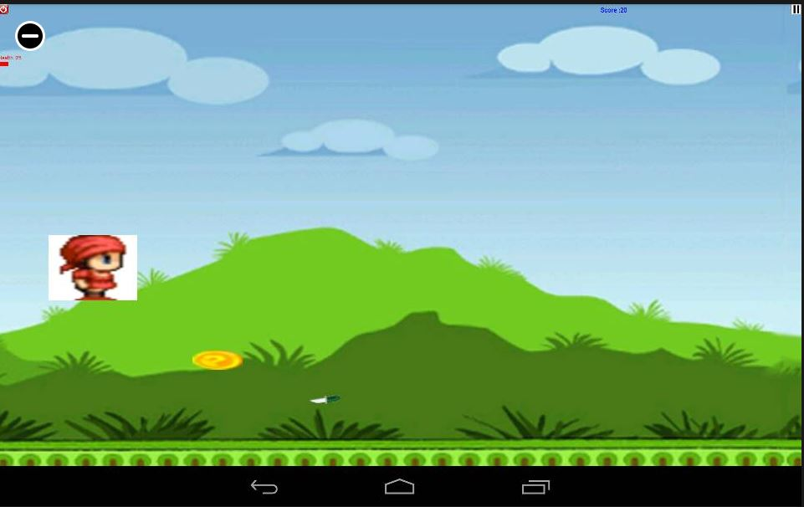

In the Thegot2run game, we replaced the on touch method with the broadcast method for accelerometer sensor data to recognize the stomp gesture and so the boy jumps accordingly as above.